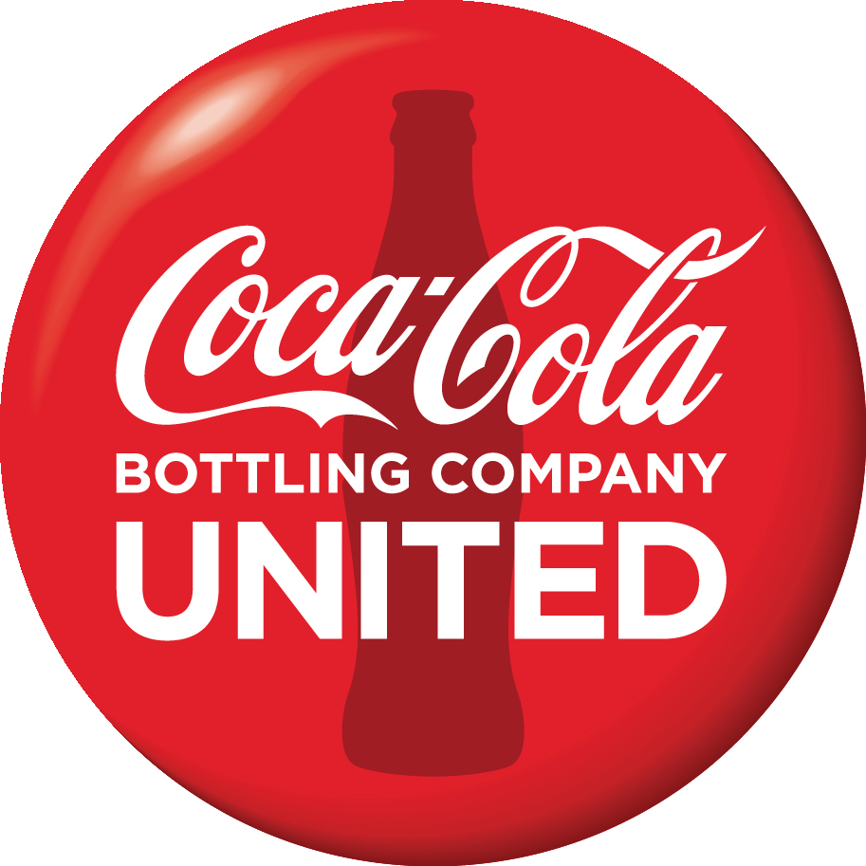
For Immediate release
Contact:
Andy Britton, Coca-Cola UNITED
andybritton@ccbcu.com
M: 334-652-9567

Coca-Cola and City of Quincy to Unveil Restored Downtown Mural
Project Highlights Unique History of the Northwest Florida Community

(October 13, 2020) Quincy, Florida- Coca-Cola Bottling Company UNITED, INC. and the City of Quincy, Florida celebrated a partnership that has lasted more than 100 years during an unveiling ceremony of a restored, historic Coca-Cola mural in downtown Quincy. The community project sought to return the luster to the 40-year-old mural located on the eastern side of the Padgett Jewelry store and culminated with today’s special event.

Community leaders from the City of Quincy, Gadsden County, and representatives from Coca-Cola UNITED, were on hand for the event that was attended by citizens from across the area. The restored mural located the intersection of Jefferson and Madison streets was presented on Tuesday and included an appearance by the iconic Coca-Cola Polar Bear and a “Coca-Cola Community Toast”.

“Coca-Cola Bottling Company UNITED is excited to celebrate the historic partnership between the city of Quincy, Florida and Coca-Cola,” said Brian Tucker, Sales Center Manager of Tallahassee Coca-Cola. “The opportunity to preserve this piece of the past is part of the foundation for the future growth of our company’s relationship with our customers and communities.”

The City of Quincy and Coca-Cola have a unique history. A banker at Quincy National Bank named “Pat” Monroe was a major investor and instrumental in the rise and early successes of a new beverage by the name of Coca-Cola. Many families in the City of Quincy saw Coca-Cola stock as a sound financial investment in the uncertain economic times of the late 1920's & early 30's.

Historically significant franchises within the Coca-Cola UNITED footprint include Columbus, Georgia, development site of the original Coca-Cola formula; Chattanooga, the world’s first Coca-Cola bottler; and Atlanta, home of the worldwide Coca-Cola System

Coca-Cola Bottling Company UNITED, headquartered in Birmingham, Alabama acquired the Quincy, Florida territory in 2017 and now serves the community from the Tallahassee Coca-Cola Sales Center.

# # #
About Coca-Cola Bottling Company United, Inc.

Coca-Cola Bottling Company United, Inc., founded in 1902 and headquartered in Birmingham, Alabama, is the second largest privately held Coca-Cola bottler in North America and the third largest bottler of Coca-Cola products in the U.S. Coca-Cola UNITED has approximately 10,000 associates located in more than 60 facilities across six southeastern states (Alabama, Florida, Georgia, Louisiana, Mississippi, and Tennessee). Historically significant franchises within our Coca-Cola UNITED family include Chattanooga, the world’s first Coca-Cola bottler; Atlanta, home of the worldwide Coca-Cola System; and Columbus, Georgia, development site of the original Coca-Cola formula.

For more than 118 years, Coca-Cola UNITED has remained true to its foundational core values of: Quality, Excellence, Integrity and Respect. Local relationships, personalized customer service, and strong community engagement have been the foundation of our business for more than a century. Each year, millions of dollars are invested in our local communities, supporting education, community development, sustainability initiatives and nonprofit organizations that empower and impact those in need.

